 |  | 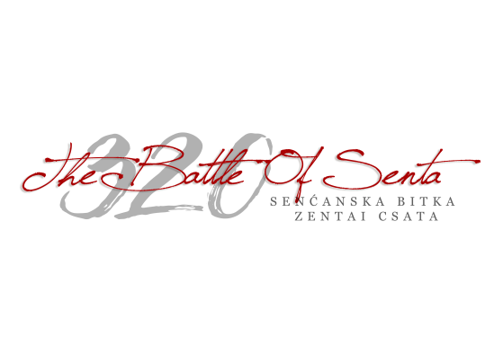  РЕПУБЛИКА СРБИЈA  SZERB KÖZTÁRSASÁG  АУТОНОМНА ПОКРАЈИНА ВОЈВОДИНА  VAJDASÁG AUTONÓM TARTOMÁNY  ОПШТИНA СЕНТА  ZENTA KÖZSÉG
24400 SENTA, Glavnitrg. 1., +381/24/ 655-411, +381/24/ 655-444, Fax: +381/24 812-034, E-mail: info@zenta-senta.co.rs, www.zenta-senta.co.rs

SUPPLY CONTRACT AWARD NOTICE
Supply the parts of the Pedal division of the organ
Senta – North Banat, Serbia

1. Type of procedure
Competitive negotiated tender

2. Publication reference and date of the contract notice
RORS-35/2017/S3, 28.02.2018.

3. Lot number and lot title
N/A

4. Contract number and value
RORS-35/2017/S3, 3.749.800 RSD

5. Date of award of the contract
03.04.2018.

6. Number of tenders received
1 (one)

7. Name, address and nationality of successful tenderer
YUMOL DOO, Grabobačka 10, 24400 Subotica, Serbia
8. Duration of contract
8 months ¬ (270 days)
9. Contracting Authority
Municipality of Senta, Glavni trg 1, 24400 Senta, Serbia
10. Legal basis
1 Regulation (EU) N°236/2014 of the European Parliament and of the Council of 11 March 2014 laying down common rules and procedures for the implementation of the Union's instruments for financing external action and
COUNCIL REGULATION (EC) No 1085/2006 of 17 July 2006 establishing an Instrument for Pre-Accession Assistance (IPA)
REGULATION (EU, EURATOM) No 966/2012 OF THE EUROPEAN PARLIAMENT AND OF THE COUNCIL of 25 October 2012 on the financial rules applicable to the general budget of the Union and repealing Council Regulation (EC, Euratom) No 1605/2002
COMMISSION DELEGATED REGULATION (EU) No 1268/2012 of 29 October 2012 on the rules of application of Regulation (EU, Euratom) No 966/2012 of the European Parliament and of the Council on the financial rules applicable to the general budget of the Union

